Construct a QA Bot that Leverages LangChain and LLMs to Answer Questions from Loaded Documents
Estimated time needed: 60 minutes
In this project, you will construct a question-answering (QA) bot. This bot will leverage LangChain and a large language model (LLM) to answer questions based on content from loaded PDF documents. To build a fully functional QA system, you'll combine various components, including document loaders, text splitters, embedding models, vector databases, retrievers, and Gradio as the front-end interface.
Imagine you're tasked with creating an intelligent assistant that can quickly and accurately respond to queries based on a company's extensive library of PDF documents. This could be anything from legal documents to technical manuals. Manually searching through these documents would be time-consuming and inefficient.

Source: DALL-E
In this project, you will construct a QA bot that automates this process. By leveraging LangChain and an LLM, the bot will read and understand the content of loaded PDF documents, enabling it to provide precise answers to user queries. You will integrate the tools and techniques, from document loading, text splitting, embedding, vector storage, and retrieval, to create a seamless and user-friendly experience via a Gradio interface.

Learning objectives
By the end of this project, you will be able to:
- Combine multiple components, such as document loaders, text splitters, embedding models, and vector databases, to construct a fully functional QA bot
- Leverage LangChain and LLMs to solve the problem of retrieving and answering questions based on content from large PDF documents

Set up

Setting up a virtual environment
Let's create a virtual environment. Using a virtual environment allows you to manage dependencies for different projects separately, avoiding conflicts between package versions.
In the terminal of your Cloud IDE, ensure that you are in the path /home/project, then run the following commands to create a Python virtual environment.
shell
pip install virtualenv
virtualenv my_env # create a virtual environment named my_env
source my_env/bin/activate # activate my_env

Run

Installing necessary libraries
To ensure seamless execution of your scripts, and considering that certain functions within these scripts rely on external libraries, it's essential to install some prerequisite libraries before you begin. For this project, the key libraries you'll need are Gradio for creating user-friendly web interfaces and IBM-watsonx-AI for leveraging advanced LLM models from the IBM watsonx API.
- **`gradio`** allows you to build interactive web applications quickly, making your AI models accessible to users with ease.
- **`ibm-watsonx-ai`** for using LLMs from IBM watsonx.ai.
- **`langchain`, `langchain-ibm`, `langchain-community`** for using relevant features from Langchain.
- **`chromadb`** for using the chroma database as a vector database.
- **`pypdf`** is required for loading PDF documents.
Here's how to install these packages (from your terminal):
shell
# installing necessary packages in my_env
python3.11 -m pip install \
gradio==4.44.0 \
jinja2==3.1.2 \
fastapi==0.110.0 \
starlette==0.36.3 \
huggingface_hub==0.23.5 \
ibm-watsonx-ai==1.1.2 \
langchain==0.2.11 \
langchain-community==0.2.10 \
langchain-ibm==0.1.11 \
chromadb==0.4.24 \
pypdf==4.3.1 \
pydantic==2.9.1

Run
Now, the environment is ready to create the application.

Construct the QA bot
It's time to construct the QA bot!
Let's start by creating a new Python file to store your bot. Click the button below to create a new Python file, and call it qabot.py. If, for whatever reason, the button does not work, make the new file by going to File --> New Text File. Be sure to save the file as qabot.py.

Open qabot.py in IDE
You will populate qabot.py in the following sections with your bot.

Import the necessary libraries
Inside qabot.py, import the following from gradio, ibm_watsonx.ai, langchain_ibm, langchain, and langchain_community. The imported classes are necessary for initializing models with the correct credentials, splitting text, initializing a vector store, loading PDFs, generating a question-answer retriever, and using Gradio.
python
from ibm_watsonx_ai.foundation_models import ModelInference
from ibm_watsonx_ai.metanames import GenTextParamsMetaNames as GenParams
from ibm_watsonx_ai.metanames import EmbedTextParamsMetaNames
from ibm_watsonx_ai import Credentials
from langchain_ibm import WatsonxLLM, WatsonxEmbeddings
from langchain.text_splitter import RecursiveCharacterTextSplitter
from langchain_community.vectorstores import Chroma
from langchain_community.document_loaders import PyPDFLoader
from langchain.chains import RetrievalQA

import gradio as gr

# You can use this section to suppress warnings generated by your code:
def warn(*args, **kwargs):
pass
import warnings
warnings.warn = warn
warnings.filterwarnings('ignore')

Initialize the LLM
You will now initialize the LLM by creating an instance of WatsonxLLM, a class in langchain_ibm. WatsonxLLM can use several underlying foundational models. In this particular example, you will use Mixtral 8x7B, although you could have used other models, such as Llama 3.3 70B. For a list of foundational models available in watsonx.ai, refer to the documentation.
To initialize the LLM, paste the following into qabot.py. Note that you are initializing the model with a temperature of 0.5, and allowing for the generation of a maximum of 256 tokens.
python
## LLM
def get_llm():
model_id = 'mistralai/mistral-medium-2505'
parameters = {
GenParams.MAX_NEW_TOKENS: 256,
GenParams.TEMPERATURE: 0.5,
}
project_id = "skills-network"
watsonx_llm = WatsonxLLM(
model_id=model_id,
url="https://us-south.ml.cloud.ibm.com",
project_id=project_id,
params=parameters,
)
return watsonx_llm

Define the PDF document loader
Next, you will define the PDF document loader. To load PDF documents, you will use the PyPDFLoader class from the langchain_community library. The syntax is quite straightforward. First, you create the PDF loader as an instance of PyPDFLoader. Then, you load the document and return the loaded document. To incorporate the PDF loader in your bot, add the following to qabot.py:
python
## Document loader
def document_loader(file):
loader = PyPDFLoader(file.name)
loaded_document = loader.load()
return loaded_document

Define the text splitter
The PDF document loader loads the document but does not split it into chunks when using the .load() method. Consequently, you must define a document splitter that will split the text into chunks. Add the following code to qabot.py to define such a text splitter. In this example, you are defining a RecursiveCharacterTextSplitter with a chunk size of 1000, although other splitters or parameter values are possible.
python
## Text splitter
def text_splitter(data):
text_splitter = RecursiveCharacterTextSplitter(
chunk_size=1000,
chunk_overlap=50,
length_function=len,
)
chunks = text_splitter.split_documents(data)
return chunks

Define the vector store
Now that you can load the PDF into text and split that text into chunks, you must define a way to embed and store those chunks in a vector database. Add the following code to qabot.py to define a function that embeds the chunks using a yet to be defined embedding model and stores the embeddings in a ChromaDB vector store:
python
## Vector db
def vector_database(chunks):
embedding_model = watsonx_embedding()
vectordb = Chroma.from_documents(chunks, embedding_model)
return vectordb

Define the embedding model
The above vector_database() function assumes the existence of a watsonx_embedding() function that loads an instance of an embedding model. This embedding model is needed to convert chunks of text into vector representations. The following code defines a watsonx_embedding() function that returns an instance of WatsonxEmbeddings, a class from langchain_ibm that generates embeddings. In this particular case, the embeddings are generated using IBM's Slate 125M English embeddings model. Paste this code into the qabot.py file:
python
## Embedding model
def watsonx_embedding():
embed_params = {
EmbedTextParamsMetaNames.TRUNCATE_INPUT_TOKENS: 3,
EmbedTextParamsMetaNames.RETURN_OPTIONS: {"input_text": True},
}
watsonx_embedding = WatsonxEmbeddings(
model_id="ibm/slate-125m-english-rtrvr-v2",
url="https://us-south.ml.cloud.ibm.com",
project_id="skills-network",
params=embed_params,
)
return watsonx_embedding

It does not matter to Python that watsonx_embedding() is defined after vector_database(). The order of these definitions could have been reversed, which would have resulted in no change in the bot's underlying functionality.

Define the retriever
Now that your vector store is defined, you must define a retriever that retrieves chunks of the document from it. In this particular case, you will define a vector store-based retriever that retrieves information using a simple similarity search. To do so, add the following lines to qabot.py:
python
## Retriever
def retriever(file):
splits = document_loader(file)
chunks = text_splitter(splits)
vectordb = vector_database(chunks)
retriever = vectordb.as_retriever()
return retriever

Define a question-answering chain
Finally, it is time to define a question-answering chain! In this particular example, you will use RetrievalQA from langchain, a chain that performs natural-language question-answering over a data source using retrieval-augmented generation (RAG). Add the following code to qabot.py to define a question-answering chain:
python
## QA Chain
def retriever_qa(file, query):
llm = get_llm()
retriever_obj = retriever(file)
qa = RetrievalQA.from_chain_type(llm=llm,
chain_type="stuff",
retriever=retriever_obj,
return_source_documents=False)
response = qa.invoke(query)
return response['result']

Let's recap how all the elements in our bot are linked. Note that RetrievalQA accepts an LLM (get_llm()) and a retriever object (an instance generated by retriever()) as arguments. However, the retriever is based on the vector store (vector_database()), which in turn needed an embeddings model (watsonx_embedding()) and chunks generated using a text splitter (text_splitter()). The text splitter, in turn, needed raw text, and this text was loaded from a PDF using PyPDFLoader. This effectively defines the core functionality of your QA bot!

Set up the Gradio interface
Given that you have created the core functionality of the bot, the final item to define is the Gradio interface. Your Gradio interface should include:
- A file upload functionality (provided by the File class in Gradio)
- An input textbox where the question can be asked (provided by the Textbox class in Gradio)
- An output textbox where the question can be answered (provided by the Textbox class in Gradio)
Add the following code to qabot.py to add the Gradio interface:
python
# Create Gradio interface
rag_application = gr.Interface(
fn=retriever_qa,
allow_flagging="never",
inputs=[
gr.File(label="Upload PDF File", file_count="single", file_types=['.pdf'], type="filepath"), # Drag and drop file upload
gr.Textbox(label="Input Query", lines=2, placeholder="Type your question here...")
],
outputs=gr.Textbox(label="Output"),
title="RAG Chatbot",
description="Upload a PDF document and ask any question. The chatbot will try to answer using the provided document."
)

Add code to launch the application
Finally, you need to add one more line to qabot.py to launch your application using port 7860:
python
# Launch the app
rag_application.launch(server_name="0.0.0.0", server_port=7860, share=True)

After adding the above line, save qabot.py.

Verify qabot.py
Your qabot.py should now look like the following:
python
from ibm_watsonx_ai.foundation_models import ModelInference
from ibm_watsonx_ai.metanames import GenTextParamsMetaNames as GenParams
from ibm_watsonx_ai.metanames import EmbedTextParamsMetaNames
from ibm_watsonx_ai import Credentials
from langchain_ibm import WatsonxLLM, WatsonxEmbeddings
from langchain.text_splitter import RecursiveCharacterTextSplitter
from langchain_community.vectorstores import Chroma
from langchain_community.document_loaders import PyPDFLoader
from langchain.chains import RetrievalQA

import gradio as gr

# You can use this section to suppress warnings generated by your code:
def warn(*args, **kwargs):
pass
import warnings
warnings.warn = warn
warnings.filterwarnings('ignore')

## LLM
def get_llm():
model_id = 'mistralai/mistral-medium-2505'
parameters = {
GenParams.MAX_NEW_TOKENS: 256,
GenParams.TEMPERATURE: 0.5,
}
project_id = "skills-network"
watsonx_llm = WatsonxLLM(
model_id=model_id,
url="https://us-south.ml.cloud.ibm.com",
project_id=project_id,
params=parameters,
)
return watsonx_llm

## Document loader
def document_loader(file):
loader = PyPDFLoader(file.name)
loaded_document = loader.load()
return loaded_document

## Text splitter
def text_splitter(data):
text_splitter = RecursiveCharacterTextSplitter(
chunk_size=1000,
chunk_overlap=50,
length_function=len,
)
chunks = text_splitter.split_documents(data)
return chunks

## Vector db
def vector_database(chunks):
embedding_model = watsonx_embedding()
vectordb = Chroma.from_documents(chunks, embedding_model)
return vectordb

## Embedding model
def watsonx_embedding():
embed_params = {
EmbedTextParamsMetaNames.TRUNCATE_INPUT_TOKENS: 3,
EmbedTextParamsMetaNames.RETURN_OPTIONS: {"input_text": True},
}
watsonx_embedding = WatsonxEmbeddings(
model_id="ibm/slate-125m-english-rtrvr-v2",
url="https://us-south.ml.cloud.ibm.com",
project_id="skills-network",
params=embed_params,
)
return watsonx_embedding

## Retriever
def retriever(file):
splits = document_loader(file)
chunks = text_splitter(splits)
vectordb = vector_database(chunks)
retriever = vectordb.as_retriever()
return retriever

## QA Chain
def retriever_qa(file, query):
llm = get_llm()
retriever_obj = retriever(file)
qa = RetrievalQA.from_chain_type(llm=llm,
chain_type="stuff",
retriever=retriever_obj,
return_source_documents=False)
response = qa.invoke(query)
return response['result']

# Create Gradio interface
rag_application = gr.Interface(
fn=retriever_qa,
allow_flagging="never",
inputs=[
gr.File(label="Upload PDF File", file_count="single", file_types=['.pdf'], type="filepath"), # Drag and drop file upload
gr.Textbox(label="Input Query", lines=2, placeholder="Type your question here...")
],
outputs=gr.Textbox(label="Output"),
title="RAG Chatbot",
description="Upload a PDF document and ask any question. The chatbot will try to answer using the provided document."
)

# Launch the app
rag_application.launch(server_name="0.0.0.0", server_port=7860, share=True)

Serve the application
To serve the application, paste the following into your Python terminal:
bash
python3.11 qabot.py

Run
If you cannot find an open Python terminal or the buttons on the above cell do not work, you can launch a terminal by going to Terminal --> New Terminal. However, if you launch a new terminal, do not forget to source the virtual environment you created at the beginning of this lab before running this line:
shell
source my_env/bin/activate # activate my_env

Launch the application
You are now ready to launch the served application! To do so, click on the following button:

Launch Application
If the above button does not work, use the following instructions:
- Select the Skills Network extension.
- Click Launch Application
- Insert the port number (in this case, 7860, which is the server port we put in qabot.py)
- Click Your application to launch the application.
Note: If the application does not work using Your Application, use the icon Open in new browser tab.
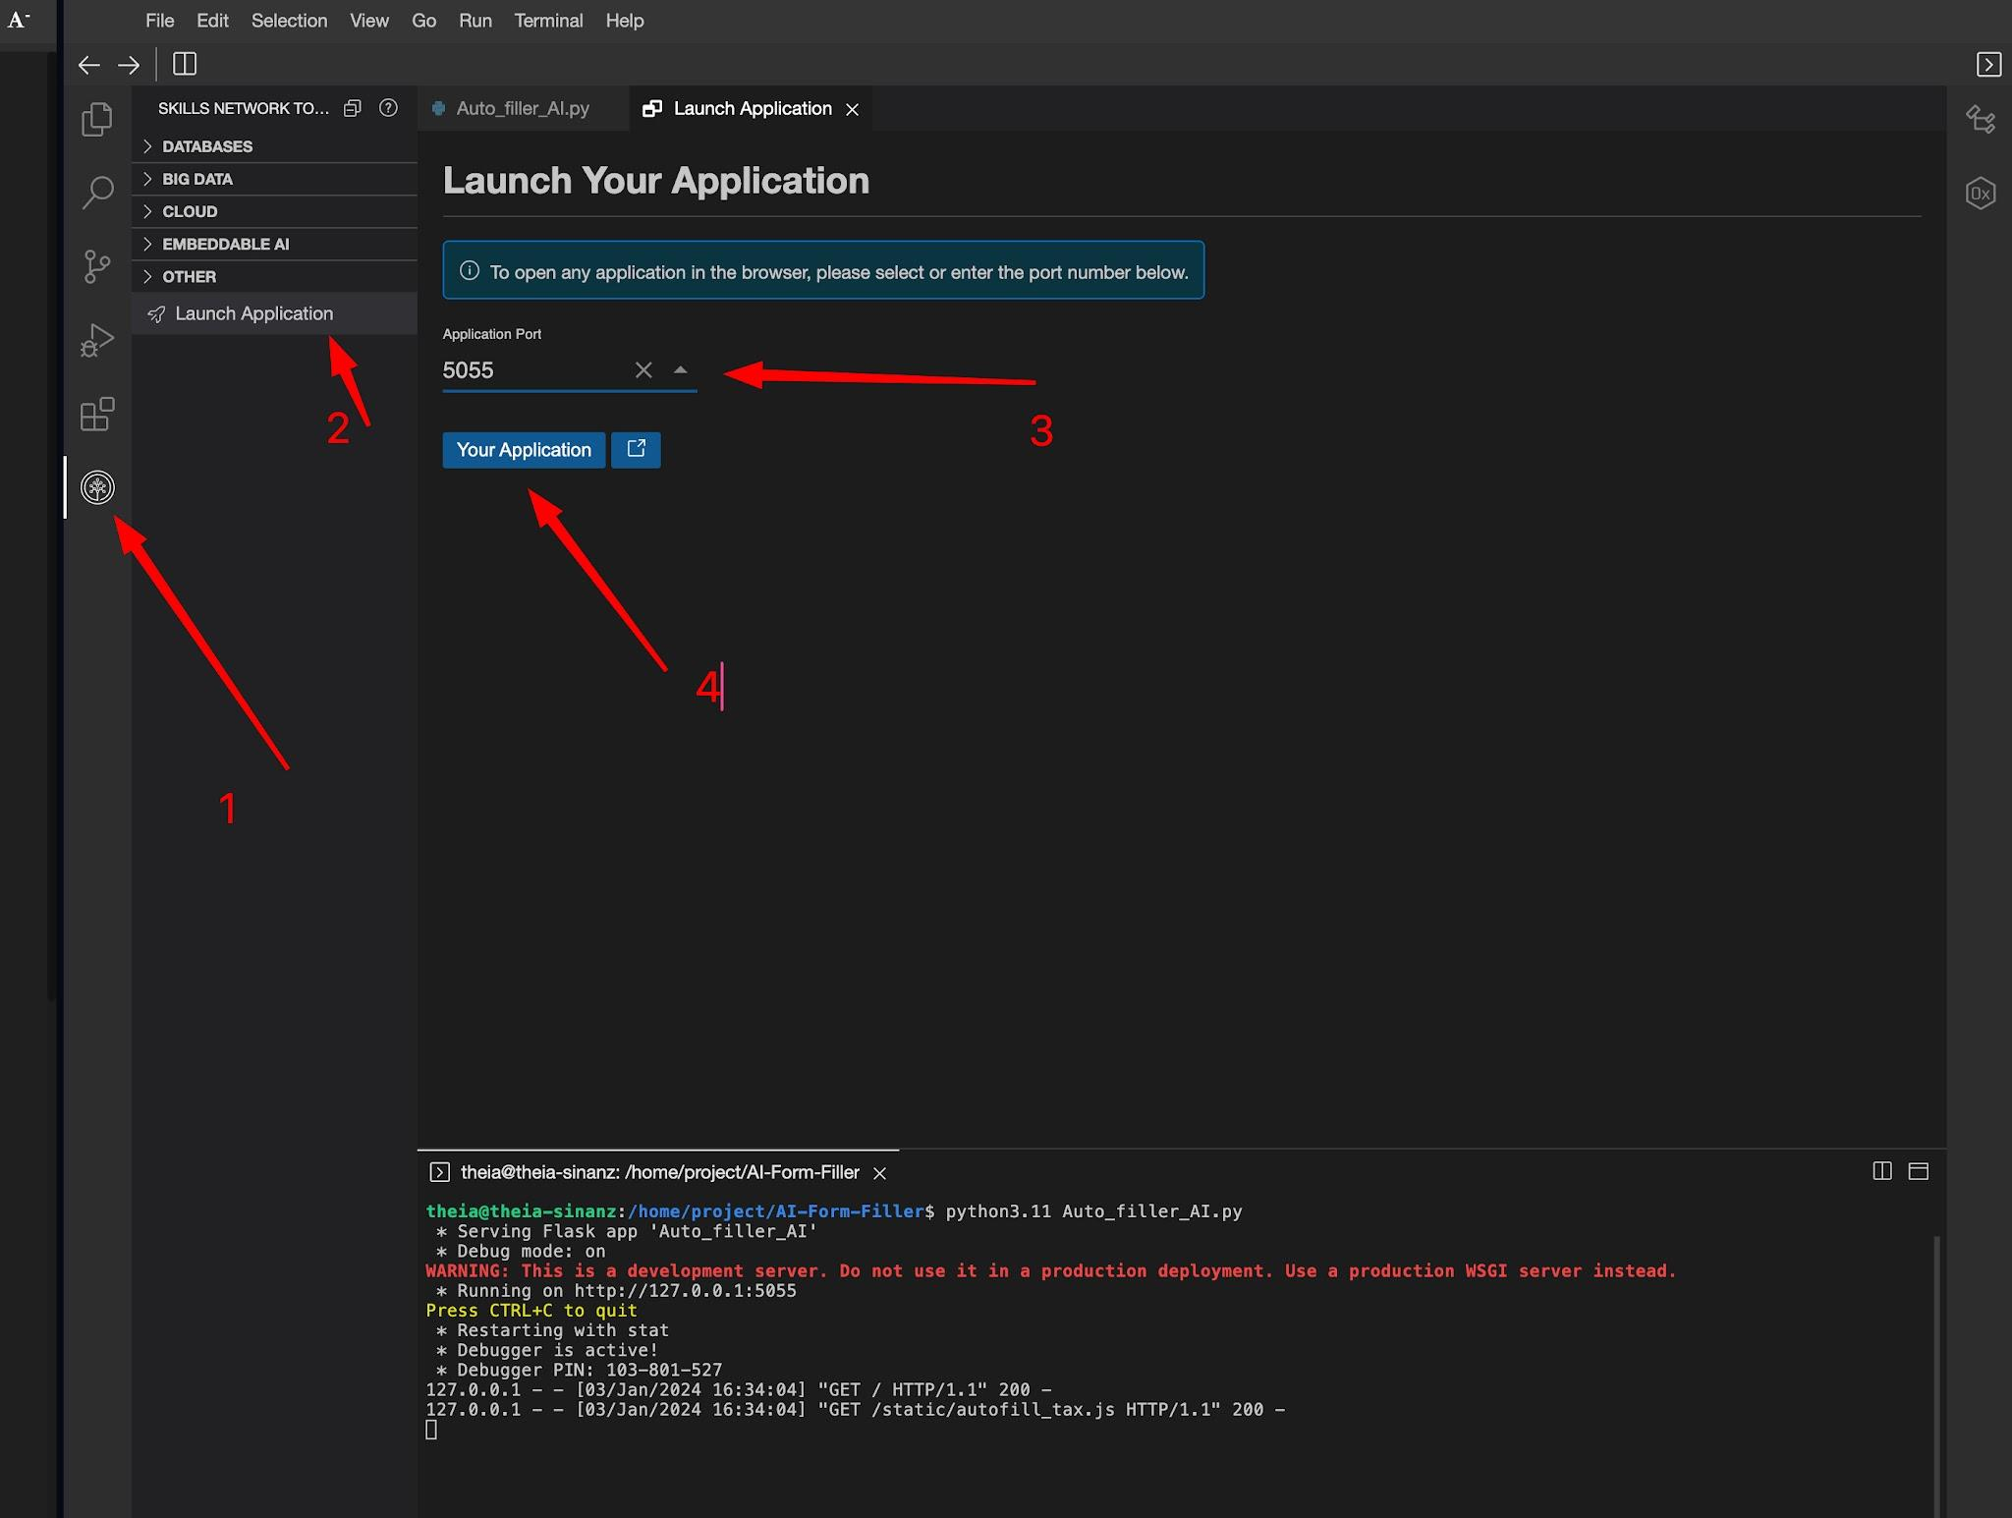
You can now interact with the application by uploading a readable PDF document and asking a question about its contents!
For best results, ensure that the PDF document is not too large. Large documents will fail with the current setup.
If you finish experimenting with the app and want to exit, press ctrl+c in the terminal and close the application tab.
Serve the applicationAuthor
The content of this lab is licensed under Apache 2.0

